The relationship in one picture:

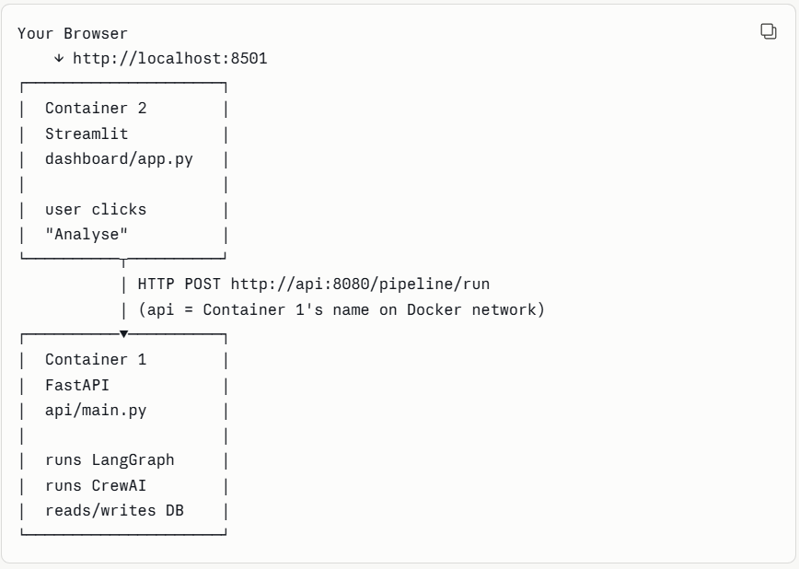

Container 2 never touches the DB directly. Never touches LangGraph directly. It just asks Container 1 via HTTP. Container 1 does all the heavy lifting.
This is the microservices pattern — each service has one job, they communicate via HTTP. Standard at every FAANG company.

